How to Input Insurance Information into Medicat Patient Portal

Step 1:
Go to https://vassar.medicatconnect.com/. Log into your patient portal. On the home screen, click on Insurance found in the top header as highlighted below.

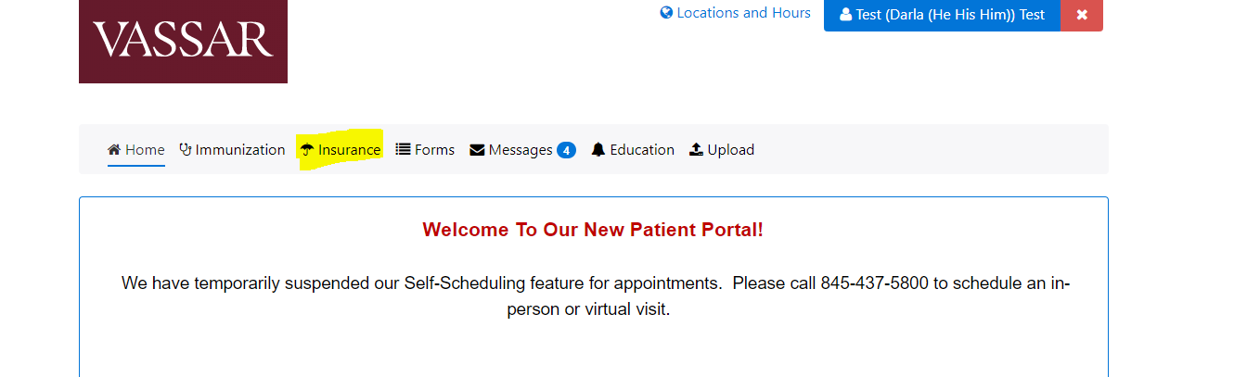

Step 2:
Click add new to enter your insurance information.

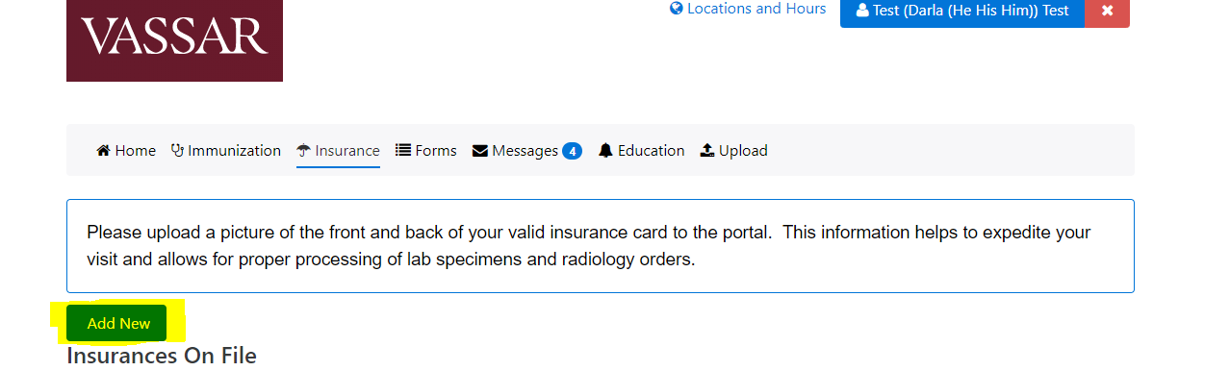
Step 3:
Enter the insurance information as directed. This information will be found on your insurance card. Please not that the information entered is for the policy holder, this might not necessarily be you. Often the policy holder is a parent, guardian, or spouse for example. The name of the policy holder will be on your insurance card. Once completed, click blue “add” button
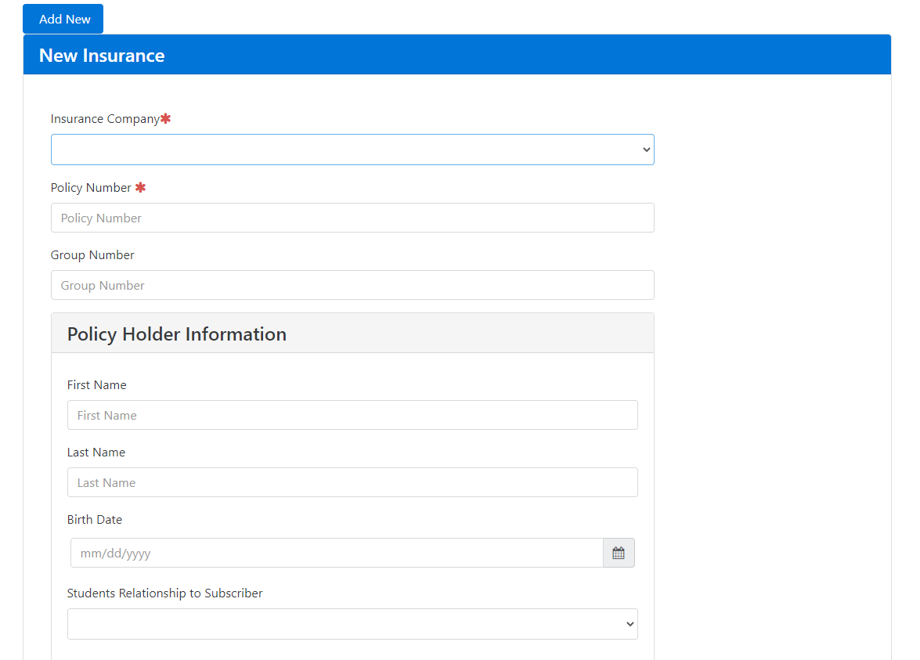

Step 4:
Upload a photo of the front and back of your card by clicking the buttons as highlighted below. You have completed the process. If you have secondary insurance, you can upload this information by using the same process.
